**Listar el nombre de la ciudad y el nombre del país de todas las ciudades que pertenezcan a países con una población menor a 10000 habitantes.**

select name,

(select name

from country

where country.code = city.countrycode) as countryName

from city

where city.countrycode IN (

select code

from country

where country.population < 10000

);

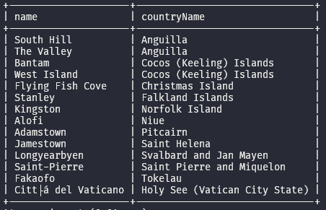

with

filter_country AS (

SELECT code as Ccode, name as Cname, population as Cpopulation

FROM country

WHERE population < 10000)

select name, Cname, Cpopulation

from city, filter_country

where city.countrycode = filter_country.Ccode;

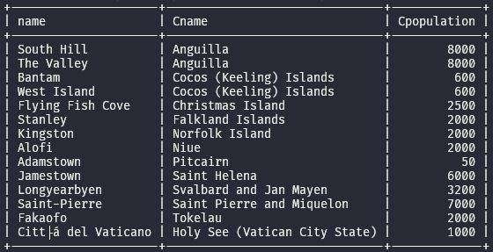

**Listar todas aquellas ciudades cuya población sea mayor que la población promedio entre todas las ciudades.**

with promedio_ciudades (promedio) as (

select avg(city2.population) as promedio

from city as city2

)

select [city1.name](http://city1.name), city1.population

from city as city1

where city1.population > (select promedio from promedio_ciudades)

order by city1.population asc;

select name

from city

where population > ALL (

select avg(population) as value

from city);

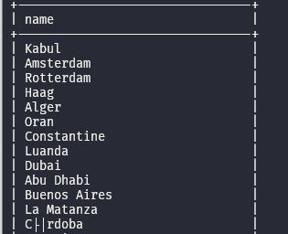

**Listar todas aquellas ciudades no asiáticas cuya población sea igual o mayor a la población total de algún país de Asia.**

with

filterCity as (

select [city.name](http://city.name) as cityName, city.population as cityPop

from city

inner join country

on city.countrycode = country.code

where country.continent != 'Asia'

)

select filterCity.cityName, filterCity.cityPop

from filterCity

where exists (

select *

from country

where country.continent = 'Asia' and filterCity.citypop >= country.population

);

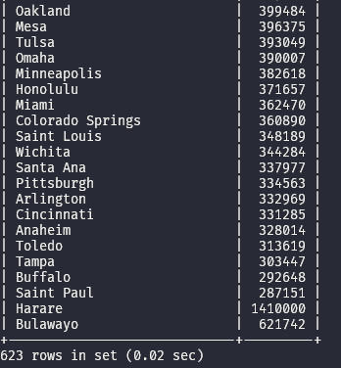

**Listar aquellos países junto a sus idiomas no oficiales, que superen en porcentaje de hablantes a cada uno de los idiomas oficiales del país.**

WITH

oficial AS (

SELECT

country.code AS ofCode,

lan.percentage AS ofLpercentage

FROM country

INNER JOIN countrylanguage AS lan

ON lan.countrycode = country.code

WHERE lan.isOfficial = 'T'

),

nooficial AS (

SELECT

country.code AS nofCode,

country.name AS nofName,

lan.language AS nofLName,

lan.percentage AS nofLpercentage

FROM country

INNER JOIN countrylanguage AS lan

ON lan.countrycode = country.code

WHERE lan.isOfficial = 'F'

)

SELECT nooficial.nofName, nooficial.nofLName

FROM nooficial

WHERE nooficial.nofLpercentage > ALL (

SELECT oficial.ofLpercentage

FROM oficial

WHERE oficial.ofCode = nooficial.nofCode

);

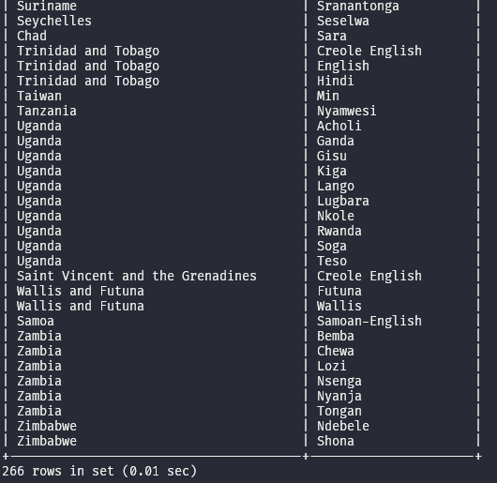

**Listar (sin duplicados) aquellas regiones que tengan países con una superficie menor a 1000 km2 y exista (en el país) al menos una ciudad con más de 100000 habitantes. (Hint: Esto puede resolverse con o sin una subquery, intenten encontrar ambas respuestas).**

Cuantas tablas necesito:

* Regiones con países con una superficie menor a 1000km2
* Los países que tengan al menos una ciudad con más de 100000

select distinct country1.region

from country as country1

where

country1.surfacearea < 1000 and

country1.code in (

select country2.code

from country as country2

where exists (

select *

from city

where city.countrycode = country2.code and city.population >= 100000

)

);

WITH

paisesConPoblacionMayor100k (codigoPais) AS (

SELECT country1.code

FROM country AS country1

WHERE EXISTS (

SELECT *

FROM city

WHERE

city.countrycode = country1.code AND

city.population >= 100000)

)

SELECT DISTINCT country2.region

FROM country as country2

WHERE country2.surfacearea < 1000 AND

country2.code IN (select codigoPais from paisesConPoblacionMayor100k);

